**Relational Model:**

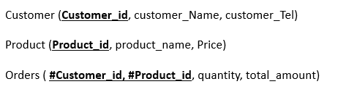

**Data types table :**

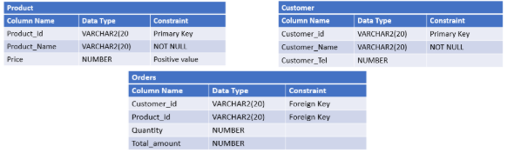

**Relational Model using SQL language:**

CREATE TABLE Customer (

Customer_id VARCHAR2(20) CONSTRAINT pk_customer PRIMARY KEY,

Customer_Name VARCHAR2(20) CONSTRAINT c_cust_name NOT NULL,

Customer_Tel NUMBER,

);

CREATE TABLE Product (

Product _id VARCHAR2(20) CONSTRAINT pk_product PRIMARY KEY,

Product _Name VARCHAR2(20) CONSTRAINT c_prod_name NOT NULL,

Price NUMBER CONSTRAINT c_price CHECK (Price>=0),

);

CREATE TABLE Orders (

Customer_id VARCHAR2(20),

Product _id VARCHAR2(20),

Quantity NUMBER,

Total_amount NUMBER,

CONSTRAINT fk_orders1 FOREIGN KEY (Customer_id) REFERENCES Customer (Customer_id),

CONSTRAINT fk_orders2 FOREIGN KEY (Product _id) REFERENCES Product (Product _id),

);

**SQL commands:**

ALTER TABLE Product ADD Category VARCHAR2(20);

ALTER TABLE Orders ADD OrderDate DATE DEFAULT SYSDATE;